The Systems Analyst Role As A Wedding Planner

Determining and Controlling the Scope:
A wedding scope would need to show the details of a wedding blueprint. For example, the wedding would need to show a list of activities. From professional wedding planner Ms. Ty Hill, CEO and Master Wedding Planner of Life and Styles Events, LLC, in Atlanta, Georgia, a scope would need to be provided for the following major activities (this list is shortened due to the extensive nature of some weddings) (T. Hill, Personal Communication, Sep 08, 2020):
Wedding Activities | Scope for Wedding Activities
Budget. | Realistic monetary planning; donations and gifts from brides family.
Parties for the bachelor and bachelorette. | Arrangement of the parties cost, the number or participants, and locale.
Bridal shower. | Arrangement of the shower and guest count.
Rehearsal dinner. | Arrange location for rehearsal and guest count.
Wedding ceremony. | Management of ceremony date and location.
Wedding reception. | Select vendors and cake maker and set date and location.
Honeymoon. | Deciding the honeymoon date and location.

Determining and Controlling the Schedule:
Controlling the schedule like a Systems Analyst is very similar to that of a wedding. For most middle class Americans these days, much of the wedding is dependent on the budget, but that is for the next section. Development and production of the schedule needs to involve activities that are grouped with tasks. A great way to organize a schedule is using a GANNT chart. These can be done online for a small fee, but the one below is a template from Microsoft Excel:

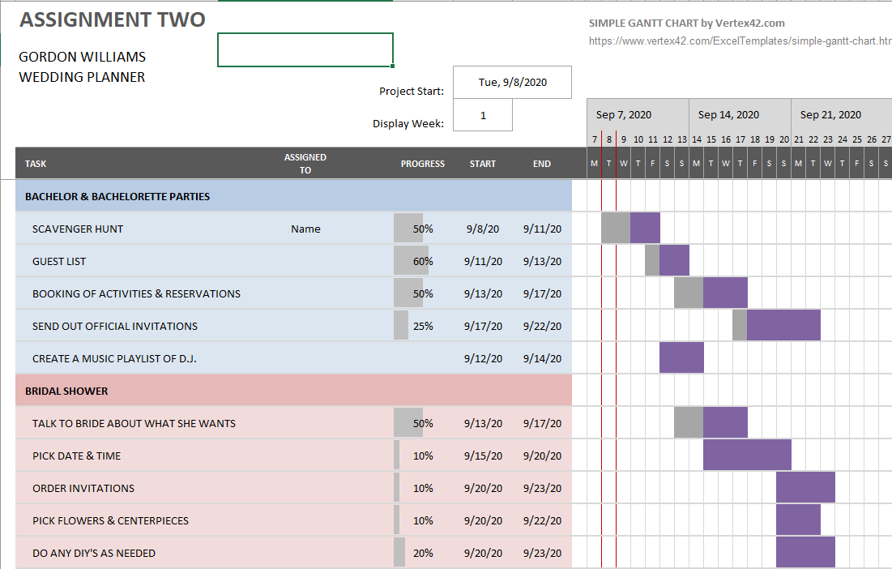

Gannt chart cont.:
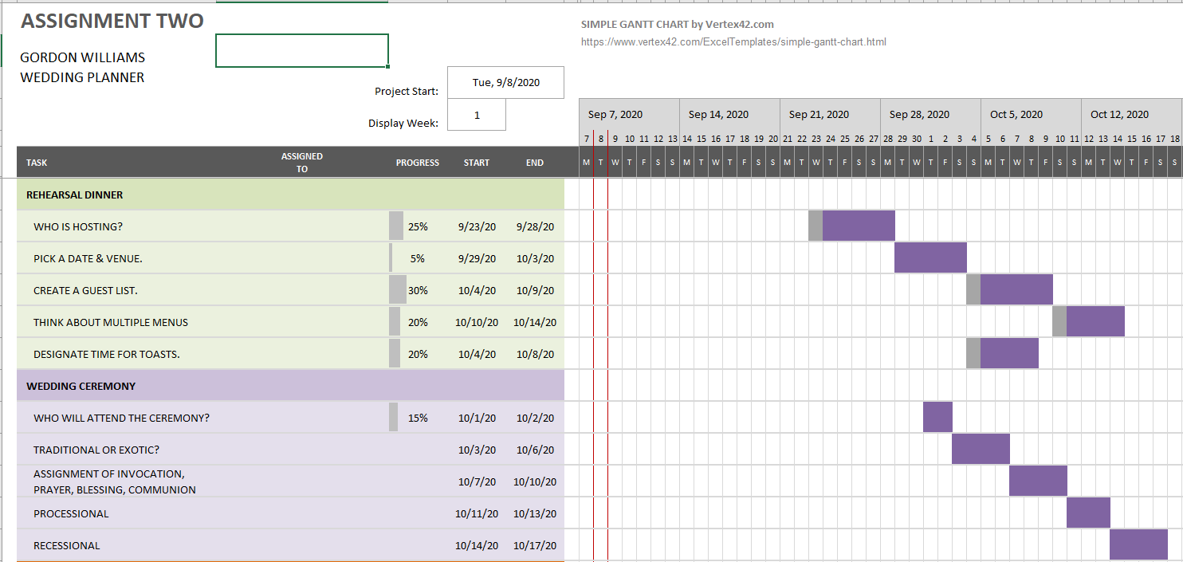
ESTIMATING THE BUDGET AND CONTROLLING THE COST:
Anticipation of the cost is the tantamount objective and distraction most couples face. “Couples around the world are going in debt by using loans and credit cards to pay for their weddings. In the US, 28% of couples reported going into debt when paying for their weddings (McDowell, 2019). While for most (women), having a dream wedding is everything, but sadly, most come down to earth. Kahn’s Catering of Texas offers seven ways to cut costs (https://blog.apastyle.org/apastyle/2016/04/how-to-cite-a-blog-post-in-apa-style.html):
- Shorten the guest list.
- Consider the overall cost of printing and sending invitations.
- Substitute your floral options (consider the seasons).
- Do it all in one place.
- Make the bar do double duty. Offer a signature drink.
- Reconsider the time and date, and finally
- Research the vendors and weigh options
HOW TO CONTROL AND MITIGATE RISKS
Projecting possible risks for failure can be very involving. The Kevin Smith Group, wedding specialists out of Phoenixville, PA, lists six of the worst wedding day risk to consider (Kevin Smith, n.d.):
- Falling behind schedule,
- Wasting valuable time at a rented venue,
- Out-of-town guests getting lost,
- Family members missing at the ceremony,
- Everyone remembering the wedding as boring, and
- Your getaway car breaking down (Kevin Smith, n.d.).

DETERMINING WHO NEEDS TO BE NOTIFIED AND HOW
Communication is vitally important on the wedding day. No matter if your wedding party is 10 people, or 1,000, a certain level of precise communication is needed for everything to fall into place. Luckily for us, todays technological advancements have enabled us to stay in touch at a moments notice with the press of a button of swipe of a screen left or right. A few of the best ways to stay in touch are group text, WhatsApp!, private Facebook group and messaging, email chains, a secret Pinterest board, Doodle, video chat, or Wedshoots (Forrest, 2018).
DETERMINING RESOURCES
Yes, yes, yes. Even with all of the great planning that goes into controlling the scope, determining a previse schedule, and knowing the risks involved, everything usually revolves around the availability of money. In the past, the primary responsibility of the financial aspects of the wedding was the father of the bride. But this was usually for a younger couple on their furst wedding. Today, the average age of a married couple is 25 to 35 years old but the average length of a marriage in the United States is only 8 years (Vinopal, 2017). By then, most fathers only invest in one marriage. So usually the only the newlyweds are, the more independent they will have to be when looking for marriage and wedding day funds. A few ways to raise money for a great wedding are as follows:
- Donations in lieu of favors,
- Donate a portion of the budget,
- Sell the wedding dress and donate proceeds,
- Dedicate all cash gifts to social impact (Burke, E, n.d.).
In closure, planning a wedding is a lot like planning the development of an application using the software development life cycle.

References
17 Sep 2019. YouTube. “Wedding Planning Checklist UK (Wedding Timeline and Checklist). Retrieved from: https://www.youtube.com/watch?v=CoU6eXLQ_nc
McDowell, E. 01 Aug 2019. “A Staggering Percentage of Couples Are Going Into Debt To Pay For Their Weddings – Here Are The Countries Where The Problem Is The Worst.” Retrieved from: https://www.businessinsider.com/wedding-cost-go-into-debt-pay-couples-2019-7
No Author. N.d. “7 Of The Best Ways To Control Wedding Costs.” Retrieved from Kahn’s Catering Blog: http://www.kahnscatering.com/blog/2016/02/7-of-the-best-ways-to-control-wedding-costs/
No Author. N.d. “6 Wedding Day Risks You Take By Not Choosing Professional Transportation Services.” Retrieved from: https://kevinsmithgroup.com/6-wedding-day-risks/
Forrest, K. 20 Dec 2018. “The 8 Best Ways To Communicate With Your Wedding Party.” Retrieved from: https://www.weddingwire.com/wedding-ideas/communicate-with-your-wedding-party
Vinopal, L. 14 Nov 2017. “A Year-By-Year Guide To Your Risk of Divorce.” Retrieved from: https://www.fatherly.com/health-science/twenty-year-guide-divorce-risk/#:~:text=Today%2C%20the%20average%20length%20of,Regardless%2C%20the%20itch%20fluctuates.
Burke, E. n.d. “8 Ways T Ask Fundraisers To Devote Their Weddings To Your Cause.” Retrieved from: https://www.classy.org/blog/ask-fundraisers-devote-weddings-cause/

